**Style Guide**

**Colour**

The game will feature a complimentary colour scheme of violets and yellows, using low lightness with high contrast colours.

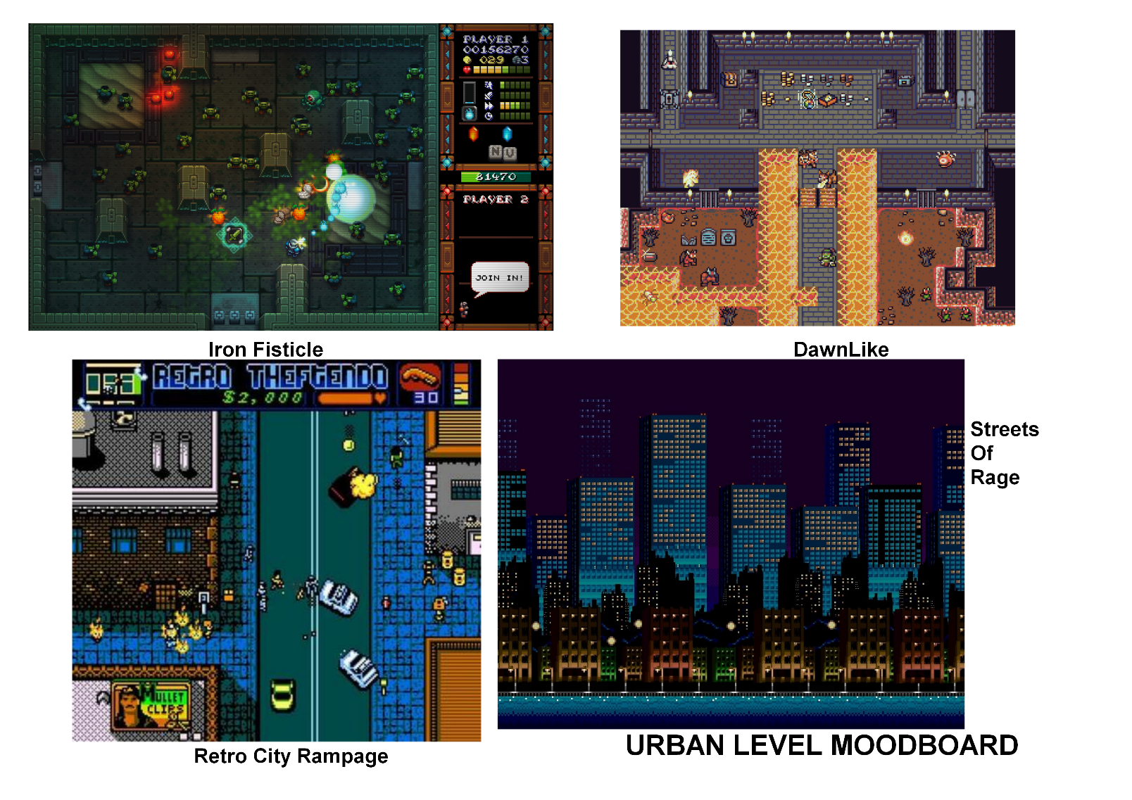

e.g. Streets of Rage uses a split complimentary scheme of green, yellow and blue violet.

**Art Direction**

Per the comedic by design mechanics of the game, an art style akin to contemporary cartoons could be utilised. A 16-bit style has been suggested, as it is easy to iterate and develop quickly.

**Tone**

Once again, the tone of the game is reflected by the game mechanics. While narration and voice acting should be avoided, comedic sound effects and animations should be used to elevate emotions associated with humour.

**Audio and Music**

The music could be inspired by pulp spy fiction, also taking inspirations from more popular media such as James Bond or the Incredibles. Sound effects could be inspired by slap stick humour, but could also use jingles in time with the players actions.

**Mood Boards**

